In a nutshell…
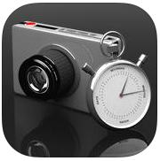Create a stop motion animation using a series of photographs. Exports to the camera roll as a movie file. Completed animation can be imported into iMovie to create voice overs, insert text and add transitions.
How to use iMotion
- Open iMotion and select NEW MOVIE
- Name as Your teacher & Table #
- Select MANUAL
- Click START
- Adjust your iPad so that your background is neatly in the frame.
- Select CAPTURE to take a photo.
- Move your Manny, select CAPTURE again.
- Continue capturing photos to create your animation. Do Not move iPad around.
- When all your frames are done, click stop.
- Click STOP again to confirm that you are done.
- Keep frames per second around 15.
- Click EXPORT to send your completed animation to the photo library.
EXTRA HINTS:
- In the OPTIONS menu you can switch the focus between auto and manual, turn the onion skin on/off (so you can see a ghost of the previous frame) and turn the grid feature on/off (helps with positioning)
- You can preview each photo and DELETE frames from the animation by using the TOOLS option before you export.

